**Question 1**

**1. Create a shellcode to exploit windows OS**



**2. Execute the shellcode on Windows**

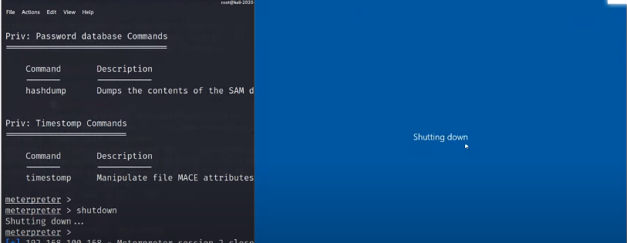

**3. Get a Meterpreter.**



**4. Upload and Download few files from the exploited system**

